Perșa Paula - Denisa

Geographic information system
8 Major Battles of WW II

A geographic information system (GIS) is a computer system for capturing, storing, checking, and displaying data related to positions on Earth’s surface. GIS can show many different kinds of data on one map, such as streets, buildings, and vegetation. This enables people to more easily see, analyze, and understand patterns and relationships.

GIS can use any information that includes location. The location can be expressed in many different ways, such as latitude and longitude, address, or ZIP code. Hundreds of thousands of organizations in virtually every field are using GIS to make maps that communicate, perform analysis, share information, and solve complex problems around the world. This is changing the way the world works.

GIS has radically changed how people create and engage with geographic information. Online maps shape the primary user experience, serving as both the means of creation and the mechanism for sharing and delivery.

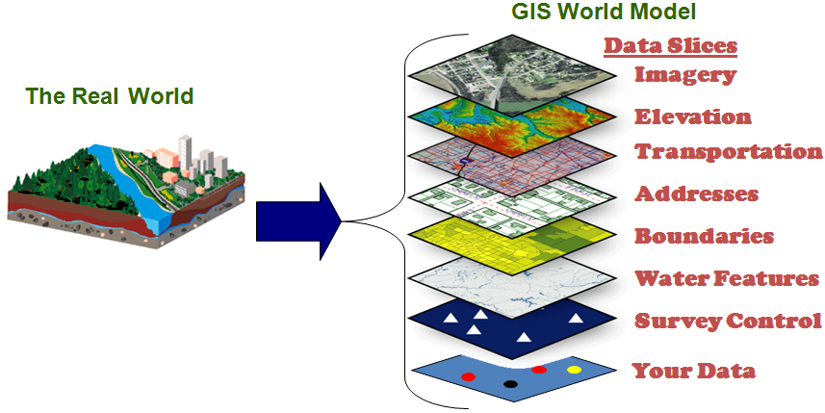
Using geographic information system, I have created a thematic layer using QGIS which indicates 8 major battles of World War II. After I did online research, this is the data set which was the base for my work:
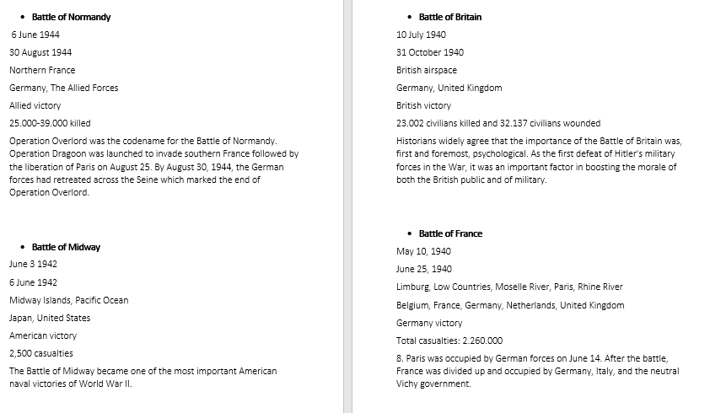

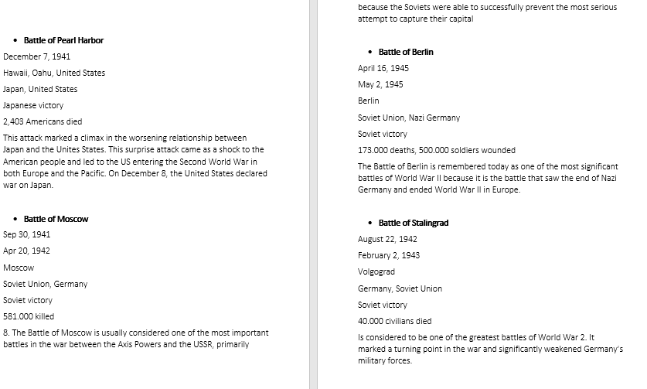
The Shapefile layer contains the following attributes:
- id - a symbol which uniquely identifies a battle
- Name – represents the name of the battle
- Start Date – indicates when the battle began
- End Date - indicates when the battle ended
- Location – marks the place where the battle took place
- Combatants – indicates the countries engaged in fighting during the battle
- Result – shows who won the battle
- Deaths – points out the number of dead/wounded soldiers
- More info – shows supplementary information about the importance of the battle

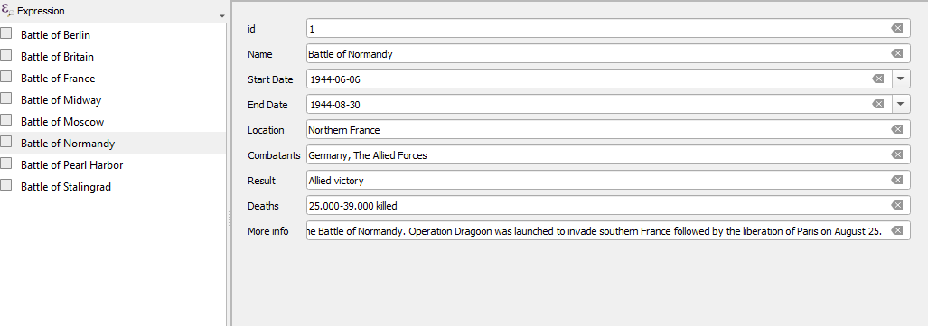

As it can be seen in the picture above, I have added 8 points to my map, each point indicating details about that battle. The map was created with the help of QuickMapServices plugin. After that, I have exported the layer in ArcGIS as a zip file.

https://arcg.is/1Kenzr

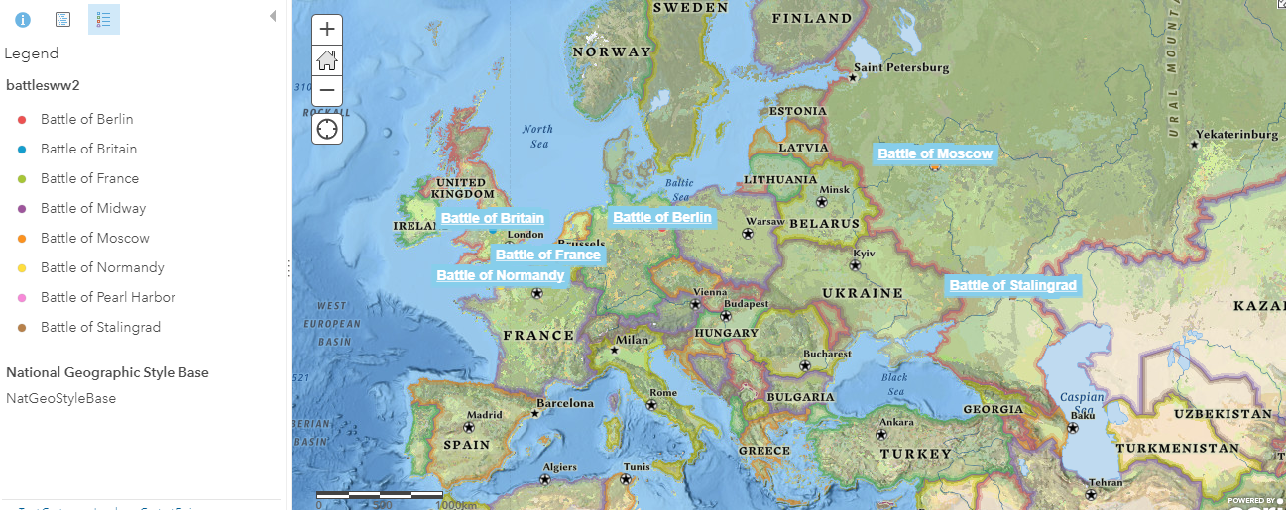

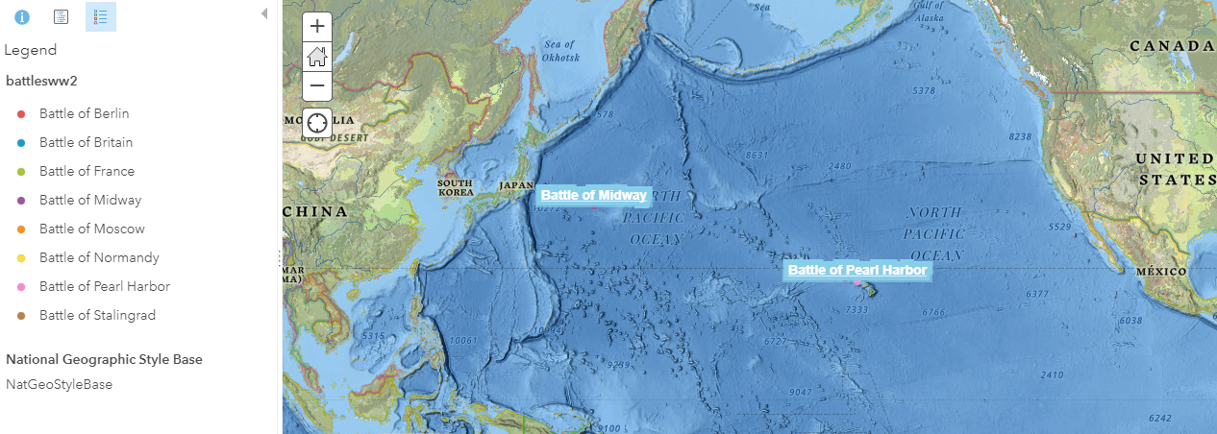

In ArcGIS, the battle’s name can be seen very easily on the left side of the project, in the legend. You can also change the style of the layer, add or modify a label.

Due to the fact that the locations of the battles could have changed on the map during the years, I tried to approximate them as well as possible.

Just by simply clicking a point on the map you can find out all the details.

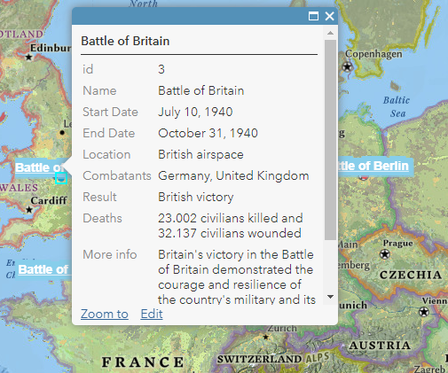

I have also created an ArcGIS story map which indicates these battles in a much more interactive form and this is how it looks like:
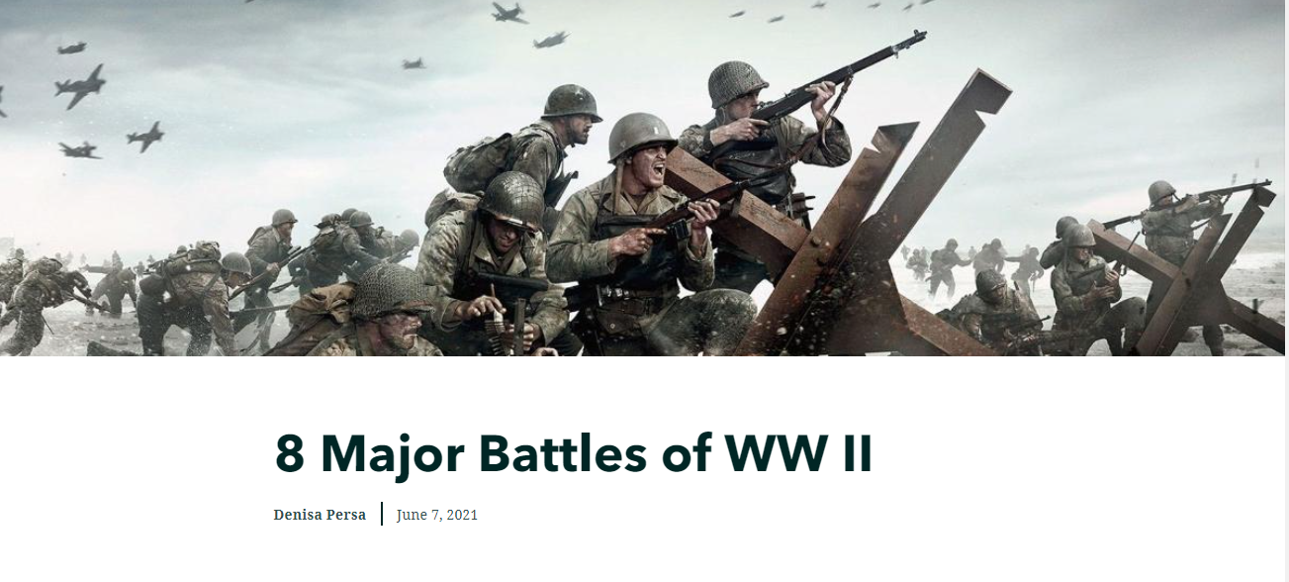
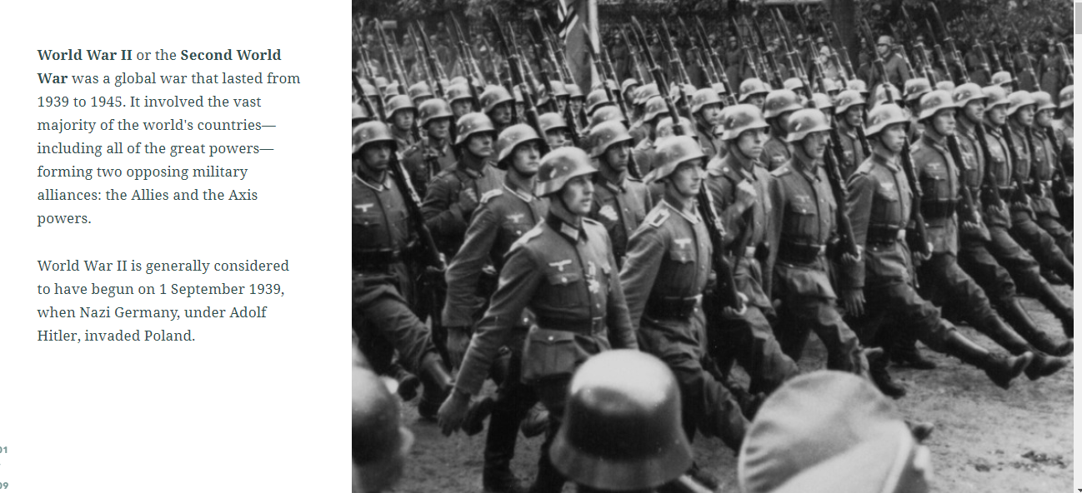

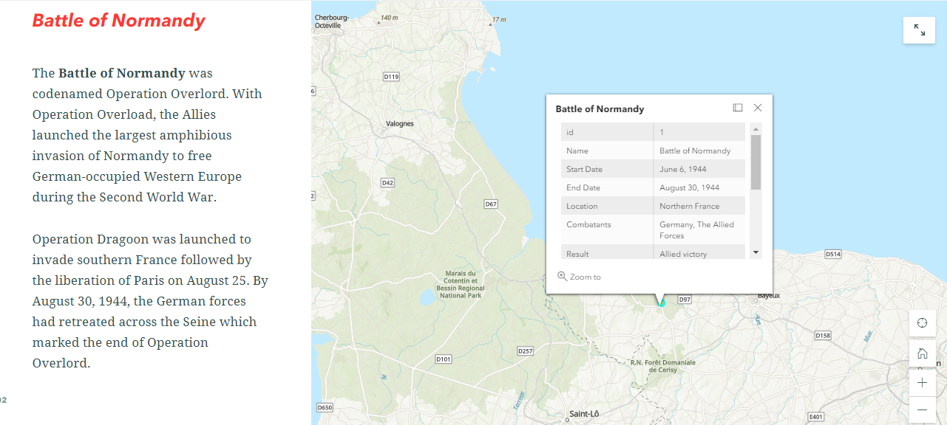

Here is the link where you can visualize it:
https://storymaps.arcgis.com/stories/77f0df693a1c4ad188bef9af2bf25d90

In conclusion, Geographic Information Systems are powerful decision-making tools for any business or industry since it allows the analyzation of environmental, demographic, and topographic data.
Bibliography

Operation Overlord - Wikipedia
The 10 Major Battles of World War II (ancienthistorylists.com)
Battle of Midway - Wikipedia
Battle of Britain - Wikipedia
Battle of France - Wikipedia
Attack on Pearl Harbor - Wikipedia
Battle of Moscow - Wikipedia
Battle of Berlin - Wikipedia
Battle of Stalingrad - Wikipedia
What is GIS? | Geographic Information System Mapping Technology (esri.com)
Geographic information system - Wikipedia

